If someone gibe up getting the good due to the tax, then he is not called as not affected by the tax though he does not pay any tax. This is called **the excess burden of the tax**, which would evenly harm consumers.

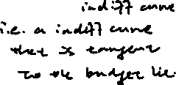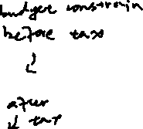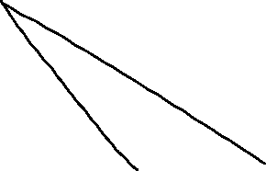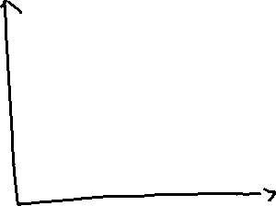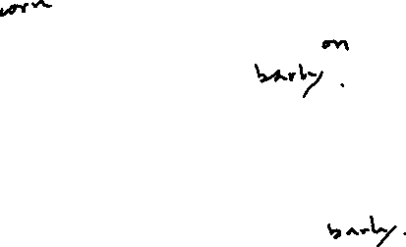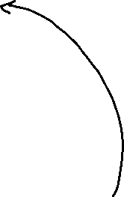

Say someone has $10 fixed income per year

He can spend either barley or corn, both goods are $1

His budget constrain is:



So, we could get a graph above:

One of the indifference curve:

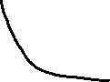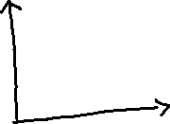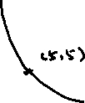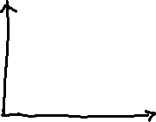

Supposed that the government implies a 100% tax on barley, that is, doubles the price of barley, then the thing would be like:

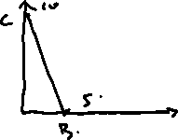

The vertical distance between the previous indifference curve and the new indifference curve is the paid tax in measured in corn.

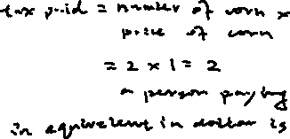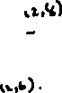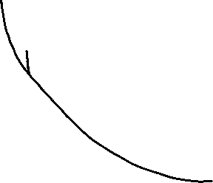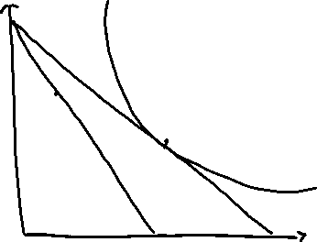

What would happen if we simply lower the income?

Then the budget line would simply shift inward.

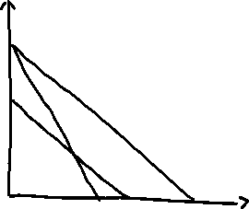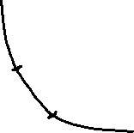

**Equivalent variation:**

**A change in income that has some effect on utility as a change on the price of a commodity.**

A lump sum tax would not lead to excess burden, but a commodity tax may cause the problem.

